AI Glasses With ESP32C6 and APP
Performance Summary

Key Takeaways
- BLE TX is the bottleneck. 10,574 ms (64% of round-trip) is spent sending audio from ESP32 to Android using WRITE_WITH_RESPONSE. Improve by:
- Switching to WRITE_WITHOUT_RESPONSE

- OpenAI pipeline adds 7.75 s. Whisper (2.5 s) + TTS (2.7 s) are the dominant API costs. Sequential execution means each call waits for the previous. Improve by:
- Stream TTS while it is still being generated would cut perceived latency significantly.

- Audio buffer nearly overflowed. Session 4 filled 99.95% of the 160 KB buffer. One longer utterance will overflow and silently truncate the response.

- RAM is healthy but tight. min_ever heap of 124 KB during Session 4 gives a good margin. The 160 KB static audio buffer is the largest single allocation, if RAM pressure increases, Improve by:
- Move to dynamic allocation.

- Battery life is ~2.6 h with no power management. Average draw of ~115 mA from a 300 mAh LiPo gives only 2.6 h. Attempt to improve Four Improvements can be done:
    - CPU frequency scaling,
    - light sleep in loop(),
    - MAX98357A SD pin gating
    - Lower BLE TX power,
Theoretically would save around 50–60 mA and push runtime to almost 4 h without any hardware changes.

- PTT during playback is silently ignored. If the user presses PTT while audio is playing, their speech is lost with no indication. An ISR-based PTT handler that stops I2S TX and switches to mic mode would fix this and improve conversational feel. Low priority

Key Results
Metric | Measured Value
End-to-End Round-Trip (M7) | 16,512 ms (16.5 s)
BLE TX Duration (M4) | 10,574 ms
OpenAI Pipeline Total (M1) | 7,754 ms
BLE Throughput (M10) | 15,195 B/s (14 KB/s)
BLE MTU Negotiated (M9) | 512 bytes
Free Heap After BLE Init (M13) | 187,064 B (182.7 KB)
Min-Ever Heap (M13) | 124,496 B (121.6 KB)
Audio Buffer Fill (M5) | 99.95% (near overflow)
I2S Switch MIC to SPK (M8) | 1 ms
I2S Switch SPK to MIC (M8) | 51 ms
Playback Duration (M12) | 3,752 ms
Avg Current Draw (M16) | ~115 mA (380 mW)
Battery Life 300 mAh (M16) | ~2.6 hours

Data Plots
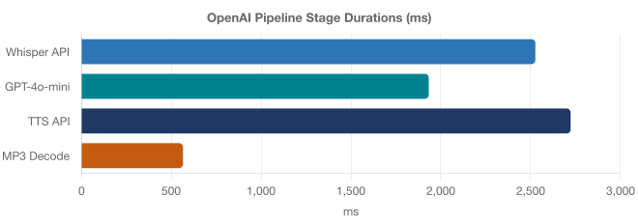
TTS API (2,722 ms) and Whisper (2,526 ms) together account for 68% of the Android processing time. GPT response is the fastest stage at 1,933 ms. MP3 decode on Android adds 566 ms. avoidable by requesting PCM output from the TTS API instead.
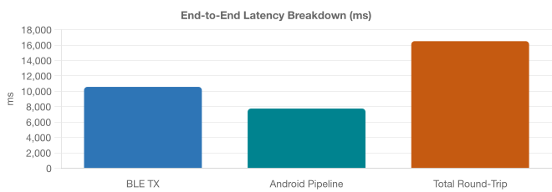
BLE transmission from ESP32 to Android (10,574 ms) exceeds the entire Android processing pipeline (7,754 ms). The total 16.5 s round-trip is dominated by BLE TX at 64%. this is the primary optimization target. Note: BLE TX and Android pipeline values are from different sessions with different utterance lengths.
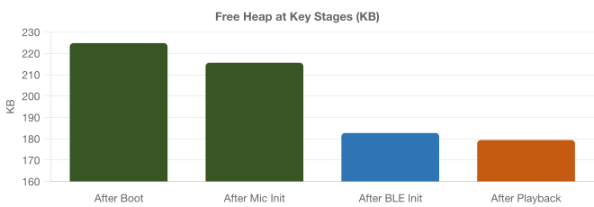
BLE stack initialization consumes ~37 KB (from 220 KB to 183 KB). After playback, 179 KB remains free comfortably above the 80 KB safety floor. The 160 KB audio buffer (always statically allocated) accounts for the largest single memory block.
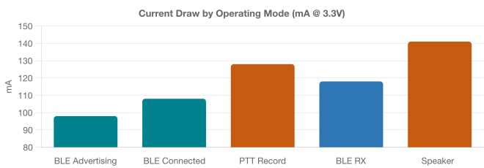
Peak draw is 141 mA during speaker playback. The relatively small spread across modes (98–141 mA) means all modes benefit from power management, particularly CPU frequency scaling and BLE TX power reduction, which together would save ~48 mA across every state.

